**Ansible Installation and configuration guide**

|  |  |  |  |
| --- | --- | --- | --- |
| **Document Name** | **Version** | **Prepared by** | **Reviewed by** |
| Ansible Installation and configuration guide | v.01 | Tarunendra Tripathi | Sumit Malhotra |
|  |  |  |  |

Contents

Introduction 1

Get the rpm to install 1

Install Ansible 2

Verify Ansible Version 2

Update Ansible configuration 2

History command 2

# Introduction

This document contains the installation and configuration of Ansible on RHEL environment.

# Get the rpm to install

Download below mentioned RPM files for installation.

ansible-2.8.5-1.el7.noarch.rpm

# Install Ansible

Install the above mentioned rpm file.

Rpm –ivh ansible-2.8.5-1.el7.noarch.rpm

# Verify Ansible Version

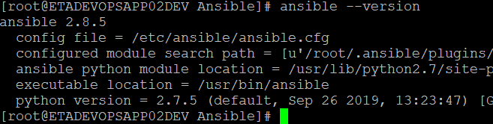

# Update Ansible configuration

vi /etc/ansible/ansible.cfg

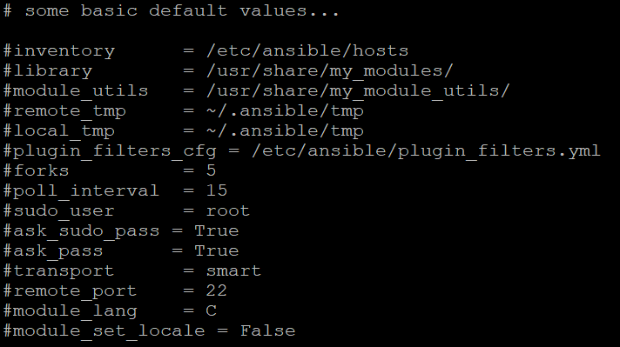

# History command

**1026 cd /opt/Ansible/**

**1027 ls -ltr**

**1028 chmod 775 *.\***

**1029 ls -ltr**

**1030 clear**

**1031 ls -ltr**

**1032 yum localinstall epel-release-latest-7.noarch.rpm**

**1033 ls -ltr**

**1034 yum localinstall python-crypto-2.6.1-1.el7.rf.x86_64.rpm**

**1035 clear**

**1036 ls -ltr**

**1037 yum localinstall python-httplib2-0.9.2-0.2.el7.noarch.rpm**

**1038 ls -ltr**

**1039 yum localinstall python-jinja2-2.7.2-4.el7.noarch.rpm**

**1040 ls -ltr**

**1041 chmod 775 python-babel-0.9.6-8.el7.noarch.rpm**

**1042 yum localinstall python-babel-0.9.6-8.el7.noarch.rpm**

**1043 yum localinstall python-jinja2-2.7.2-4.el7.noarch.rpm**

**1044 ls -ltr**

**1045 chmod 775 python-markupsafe-0.11-10.el7.x86_64.rpm**

**1046 yum localinstall python-markupsafe-0.11-10.el7.x86_64.rpm**

**1047 yum localinstall python-jinja2-2.7.2-4.el7.noarch.rpm**

**1048 clear**

**1049 ls -ltr**

**1050 yum localinstall python-keyczar-0.71c-2.el7.noarch.rpm**

**1051 ls -ltr**

**1052 chmod 775 python2-pyasn1-0.1.9-7.el7.noarch.rpm**

**1053 yum localinstall python2-pyasn1-0.1.9-7.el7.noarch.rpm**

**1054 yum localinstall python-keyczar-0.71c-2.el7.noarch.rpm**

**1055 ls -ltr**

**1056 yum localinstall sshpass-1.06-1.el7.x86_64.rpm**

**1057 pwd**

**1058 ls -ltr**

**1059 yum localinstall ansible-2.8.5-1.el7.noarch.rpm**

**1060 ls -ltr**

**1061 chmod 775 PyYAML-3.10-11.el7.x86_64.rpm**

**1062 ls -ltr**

**1063 yum localinstall PyYAML-3.10-11.el7.x86_64.rpm**

**1064 ls -ltr**

**1065 chmod 775 libyaml-0.1.4-11.el7_0.x86_64.rpm**

**1066 yum localinstall libyaml-0.1.4-11.el7_0.x86_64.rpm**

**1067\***

**1068 yum localinstall PyYAML-3.10-11.el7.x86_64.rpm**

**1069 yum localinstall ansible-2.8.5-1.el7.noarch.rpm**

**1070 ls -ltr**

**1071 chmod 775 python-paramiko-2.1.1-0.10.el7.noarch.rpm**

**1072 yum localinstall python-paramiko-2.1.1-0.10.el7.noarch.rpm**

**1073 ls -ltr**

**1074 chmod 775 python2-cryptography-1.7.2-2.el7.x86_64.rpm**

**1075 yum localinstall python2-cryptography-1.7.2-2.el7.x86_64.rpm**

**1076 ls -ltr**

**1077 chmod 775 python-cffi-1.6.0-5.el7.x86_64.rpm**

**1078 yum localinstall python-cffi-1.6.0-5.el7.x86_64.rpm**

**1079 ls -ltr**

**1080 chmod 775 python-pycparser-2.14-1.el7.noarch.rpm**

**1081 yum localinstall python-pycparser-2.14-1.el7.noarch.rpm**

**1082 ls -ltr**

**1083 chmod 775 python-ply-3.4-11.el7.noarch.rpm**

**1084 yum localinstall python-ply-3.4-11.el7.noarch.rpm**

**1085 ls -ltr**

**1086 yum localinstall python-pycparser-2.14-1.el7.noarch.rpm**

**1087 ls -ltr**

**1088 yum localinstall python-cffi-1.6.0-5.el7.x86_64.rpm**

**1089\***

**1090 yum localinstall python2-cryptography-1.7.2-2.el7.x86_64.rpm**

**1091 ls -ltr**

**1092 chmod 775 python-idna-2.4-1.el7.noarch.rpm**

**1093 yum localinstall python-idna-2.4-1.el7.noarch.rpm**

**1094 yum localinstall python2-cryptography-1.7.2-2.el7.x86_64.rpm**

**1095 ls -ltr**

**1096 chmod 775 python-enum34-1.0.4-1.el7.noarch.rpm**

**1097 yum localinstall python-enum34-1.0.4-1.el7.noarch.rpm**

**1098 ls -ltr**

**1099 yum localinstall python-idna-2.4-1.el7.noarch.rpm**

**1100 yum localinstall python-enum34-1.0.4-1.el7.noarch.rpm**

**1101 ls -ltr**

**1102 yum localinstall python2-cryptography-1.7.2-2.el7.x86_64.rpm**

**1103 ls -ltr**

**1104 yum localinstall python-paramiko-2.1.1-0.10.el7.noarch.rpm**

**1105 ls -ltr**

**1106 yum localinstall libyaml-0.1.4-11.el7_0.x86_64.rpm**

**1107 yum localinstall ansible-2.8.5-1.el7.noarch.rpm**

**1108 yum localinstall python2-jmespath**

**1109 clear**

**1110 ls -ltr**

**1111 chmod 775 python2-jmespath-0.9.4-2.el7.noarch.rpm**

**1112 yum localinstall python2-jmespath-0.9.4-2.el7.noarch.rpm**

**1113 yum localinstall ansible-2.8.5-1.el7.noarch.rpm**

**1114 ansible –version**